Knapsack Problem using dynamic programming=
#include <stdio.h>

int max(int a, int b) {
return (a > b) ? a : b;
}

int knapsack(int W, int wt[], int val[], int n) {
int dp[n + 1][W + 1];
for (int i = 0; i <= n; i++) {
for (int w = 0; w <= W; w++) {
if (i == 0 || w == 0)
dp[i][w] = 0;
else if (wt[i - 1] <= w)
dp[i][w] = max(val[i - 1] + dp[i - 1][w - wt[i - 1]], dp[i - 1][w]);
else
dp[i][w] = dp[i - 1][w];
}
}
int res = dp[n][W];
printf("Maximum value: %d\n", res);

printf("Items selected (index starting at 1): ");
int w = W;
for (int i = n; i > 0 && res > 0; i--) {
if (res == dp[i - 1][w]) {
continue;
} else {
printf("%d ", i);
res -= val[i - 1];
w -= wt[i - 1];
}
}
printf("\n");
return dp[n][W];
}
int main() {
int n, W;
printf("Enter number of items: ");
scanf("%d", &n);
int val[n], wt[n];

printf("Enter values: ");
for (int i = 0; i < n; i++)
scanf("%d", &val[i]);

printf("Enter weights: ");
for (int i = 0; i < n; i++)
scanf("%d", &wt[i]);

printf("Enter maximum capacity: ");
scanf("%d", &W);

knapsack(W, wt, val, n);
return 0;
}
Output=
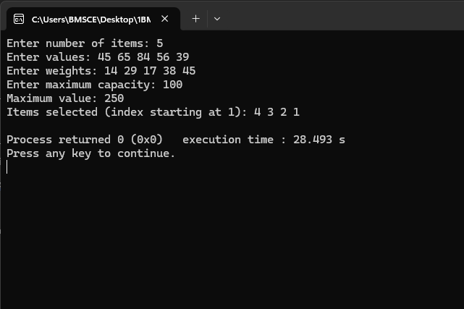

Floyd Warshall’s Algorithm=
#include <stdio.h>
#define INF 999

int main() {
int n;
printf("Enter number of vertices: ");
scanf("%d", &n);
int dist[n][n];

printf("Enter adjacency matrix (use %d for no edge):\n", INF);
for (int i = 0; i < n; i++)
for (int j = 0; j < n; j++)
scanf("%d", &dist[i][j]);

for (int k = 0; k < n; k++)
for (int i = 0; i < n; i++)
for (int j = 0; j < n; j++)
if (dist[i][k] + dist[k][j] < dist[i][j])
dist[i][j] = dist[i][k] + dist[k][j];

printf("Shortest distances between every pair of vertices:\n");
for (int i = 0; i < n; i++) {
for (int j = 0; j < n; j++) {
if (dist[i][j] == INF)
printf("INF ");
else
printf("%d ", dist[i][j]);
}
printf("\n");
}

return 0;
}
